IMPASTO PAINTING
*EXAMPLE PACKET*
(Painting in the style of Australian artist Joshua Miels)
Important Artistic Processes and Ideas:
Impasto: painting in thick heavy layers, paint is often mixed with a thickener.
Color Theory: use of a color scheme to portray a particular mood, feeling, or meaning.
Layered Drying: drying each layer of brush strokes BEFORE applying the next layer of paint
Rhythm: an art principle that posits repeated shapes, patterns, and contours increase visual interest

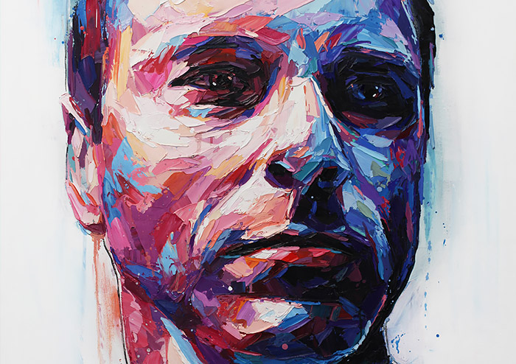

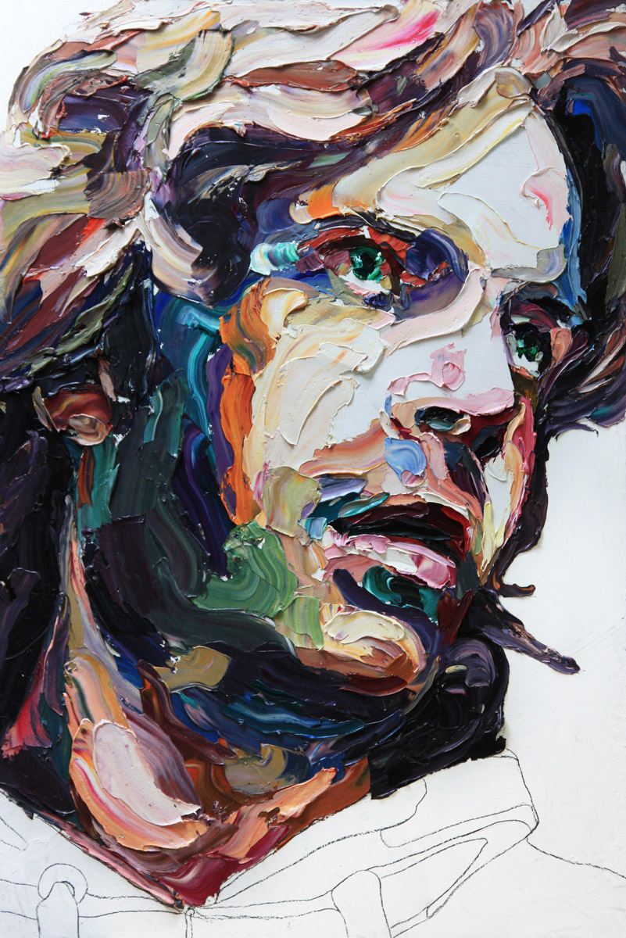

The painting process starts with an outline sketch. Paint is heavily applied and dried layer by layer so it does not mix with under-coats of paint. The artist chooses a deliberate color scheme to use in the work.

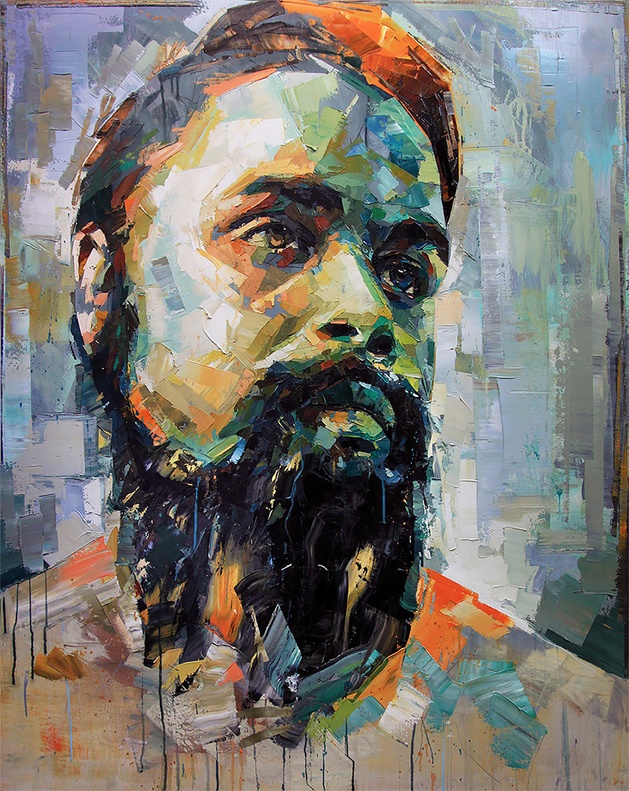

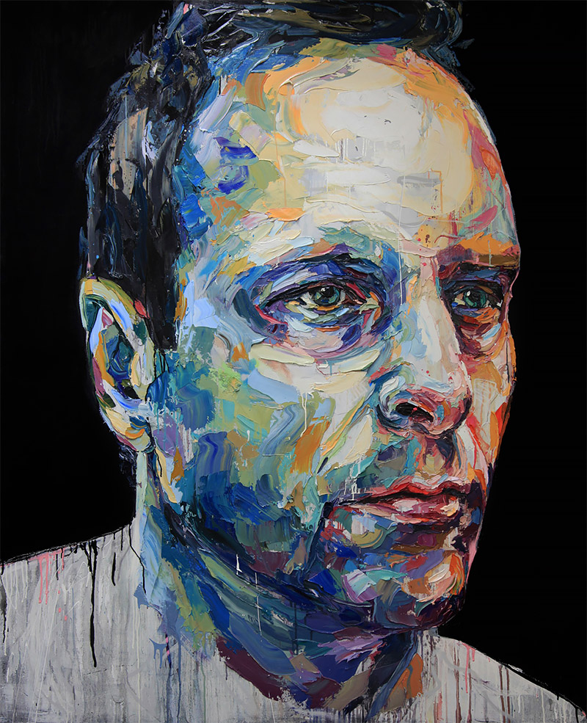

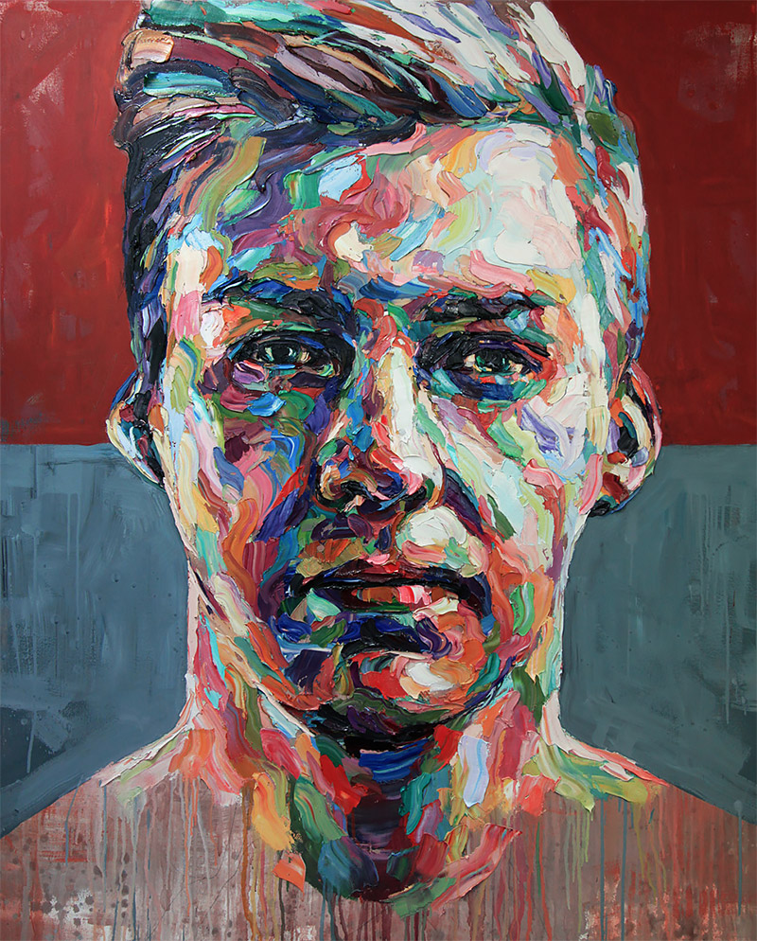

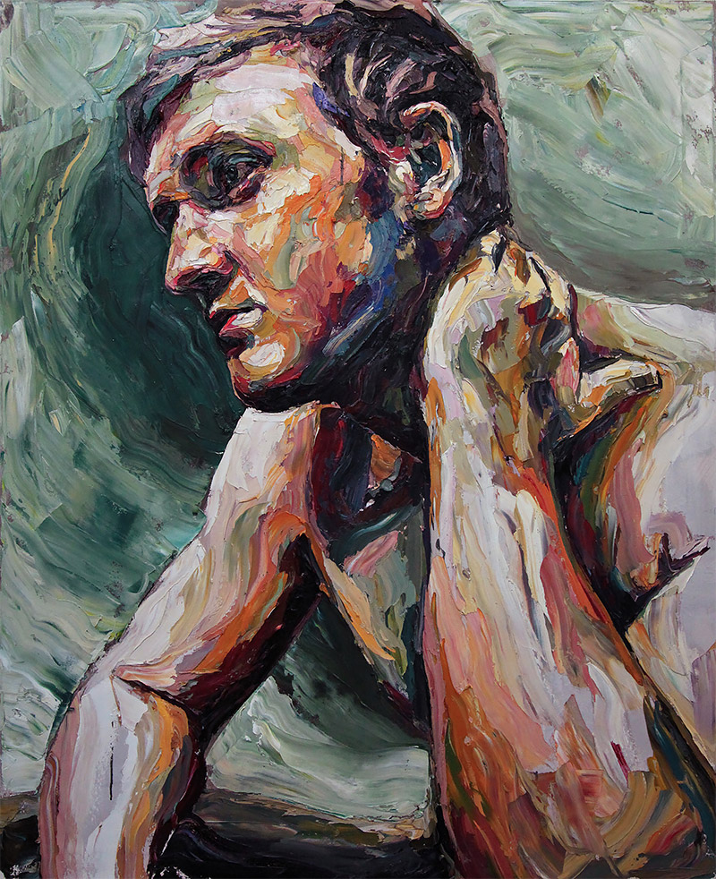

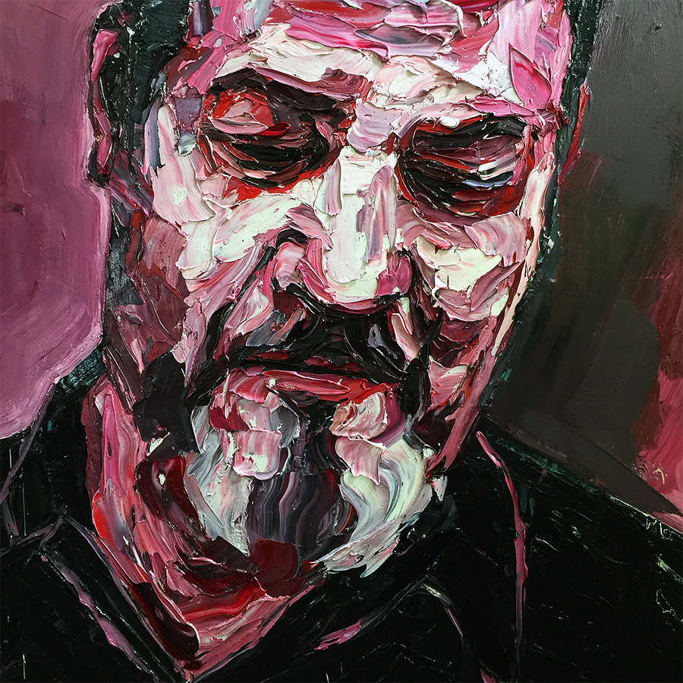

ARTIST SPOTLIGHT:
JOSHUA MIELS
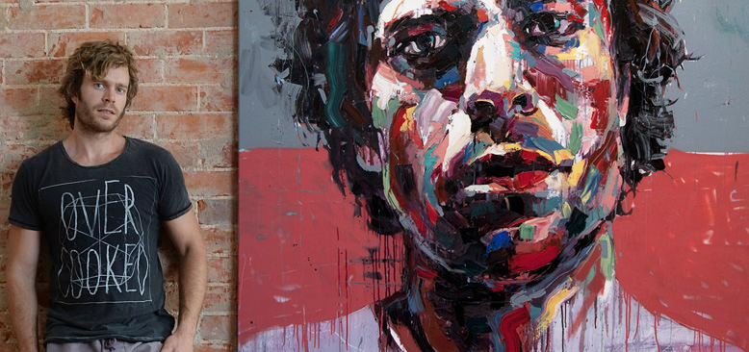
Joshua Miels is an Australian contemporary portrait artist who aims to “capture the vulnerability of people and the emotions that people try to hide from others”.
“Spending countless hours adding layer upon layer of paint Joshua produces artworks that are not only striking but deep and powerful. Painted with predominantly oil paint, each piece starts off with a subject, but with a large amount of experimentation, each art piece has its own journey on how it gets from start to finish. The artwork challenges viewers to draw upon their own emotions and personal experiences.
How each piece is interpreted differs from person to person, there is no right or wrong way to interprets these artworks.”

